**What is a Matrix?**

A matrix is a 2-dimensional array that has m number of rows and n number of columns. In other words, matrix is a combination of two or more vectors with the same data type.

**Note:** It is possible to create more than two dimensions arrays with R.

[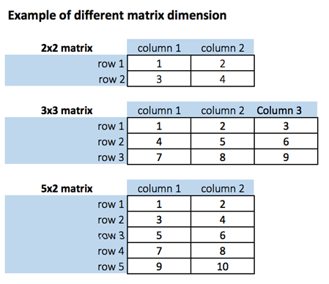](https://www.guru99.com/images/r_programming/032918_1422_RMatrixTuto1.png)

We can create a matrix with the function matrix(). This function takes three arguments:

matrix(data, nrow, ncol, byrow = FALSE)

Arguments:

- data: The collection of elements that R will arrange into the rows and columns of the matrix

- nrow: Number of rows

- ncol: Number of columns

- byrow: The rows are filled from the left to the right. We use `byrow = FALSE` (default values), if we want the matrix to be filled by the columns i.e. the values are filled top to bottom.

Let's construct two 5x2 matrix with a sequence of number from 1 to 10, one with byrow = TRUE and one with byrow = FALSE to see the difference.

# Construct a matrix with 5 rows that contain the numbers 1 up to 10 and byrow = TRUE

matrix_a <-matrix(1:10, byrow = TRUE, nrow = 5)

matrix_a

**Output:**

[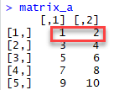](https://www.guru99.com/images/r_programming/032918_1422_RMatrixTuto2.png)

# Print dimension of the matrix with dim()

dim(matrix_a)

**Output:**

## [1] 5 2

# Construct a matrix with 5 rows that contain the numbers 1 up to 10 and byrow = FALSE

matrix_b <-matrix(1:10, byrow = FALSE, nrow = 5)

matrix_b

**Output:**

[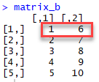](https://www.guru99.com/images/r_programming/032918_1422_RMatrixTuto3.png)

# Print dimension of the matrix with dim()

dim(matrix_b)

**Output:**

## [1] 5 2

**Note**: Using command matrix_b <-matrix(1:10, byrow = FALSE, ncol = 2) will have same effect as above.

You can also create a 4x3 matrix using ncol. R will create 3 columns and fill the row from top to bottom. Check an example

matrix_c <-matrix(1:12, byrow = FALSE, ncol = 3)

matrix_c

**Output:**

## [,1] [,2] [,3]

## [1,] 1 5 9

## [2,] 2 6 10

## [3,] 3 7 11

## [4,] 4 8 12

dim(matrix_c)

**Output:**

## [1] 4 3

You can add a column to a matrix with the cbind() command. cbind() means column binding. cbind()can concatenate as many matrix or columns as specified. For example, our previous example created a 5x2 matrix. We concatenate a third column and verify the dimension is 5x3

# concatenate c(1:5) to the matrix_a

matrix_a1 <- cbind(matrix_a, c(1:5))

# Check the dimension

dim(matrix_a1)

**Output:**

## [1] 5 3

matrix_a1

**Output**

## [,1] [,2] [,3]

## [1,] 1 2 1

## [2,] 3 4 2

## [3,] 5 6 3

## [4,] 7 8 4

## [5,] 9 10 5

We can also add more than one column. Let's see the next sequence of number to the matrix_a2 matrix. The dimension of the new matrix will be 4x6 with number from 1 to 24.

matrix_a2 <-matrix(13:24, byrow = FALSE, ncol = 3)

**Output:**

## [,1] [,2] [,3]

## [1,] 13 17 21

## [2,] 14 18 22

## [3,] 15 19 23

## [4,] 16 20 24

matrix_c <-matrix(1:12, byrow = FALSE, ncol = 3)

matrix_d <- cbind(matrix_a2, matrix_c)

dim(matrix_d)

**Output:**

## [1] 4 6

**NOTE**: The number of rows of matrices should be equal for cbind work

cbind()concatenate columns, rbind() appends rows. Let's add one row to our matrix_c matrix and verify the dimension is 6x3

matrix_c <-matrix(1:12, byrow = FALSE, ncol = 3)

# Create a vector of 3 columns

add_row <- c(1:3)

# Append to the matrix

matrix_c <- rbind(matrix_b, add_row)

# Check the dimension

dim(matrix_c)

**Output:**

## [1] 6 3

**Slice a Matrix**

We can select elements one or many elements from a matrix by using the square brackets [ ]. This is where slicing comes into the picture.

For example:

* matrix_c[1,2] selects the element at the first row and second column.
* matrix_c[1:3,2:3] results in a matrix with the data on the rows 1, 2, 3 and columns 2, 3,
* matrix_c[,1] selects all elements of the first column.
* matrix_c[1,] selects all elements of the first row.